**Course 2**

**ASK QUESTIONS TO MAKE DATA-DRIVEN DECISIONS**

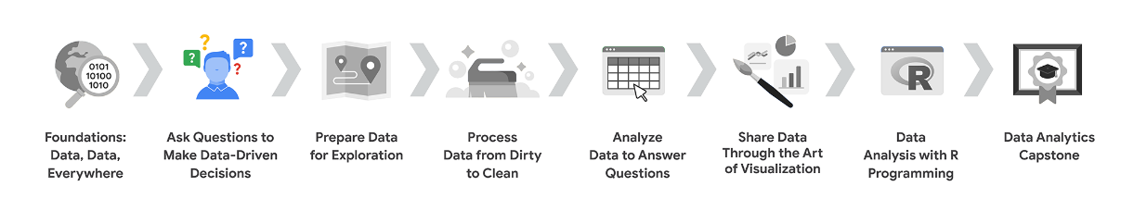

## **Course Overview**

1. [Foundations: Data, Data, Everywhere](https://www.coursera.org/learn/foundations-data/home/welcome)
2. **Ask Questions to Make Data-Driven Decisions** (this course) <- WE ARE HERE
3. [Prepare Data for Exploration](https://www.coursera.org/learn/data-preparation/home/welcome)
4. [Process Data from Dirty to Clean](https://www.coursera.org/learn/process-data/home/welcome)
5. [Analyze Data to Answer Questions](https://www.coursera.org/learn/ask-questions-make-decisions/supplement/9B242/course-2-overview-set-your-expectations)
6. [Share Data Through the Art of Visualization](https://www.coursera.org/learn/visualize-data/home/welcome)
7. [Data Analysis with R Programming](https://www.coursera.org/learn/data-analysis-r/home/welcome)
8. [Google Data Analytics Capstone: Complete a Case Study](https://www.coursera.org/learn/google-data-analytics-capstone/home/welcome)

## 

## 

## 

## 

## **COURSE 2 CONTENT**

Each course is broken into modules. Here’s a quick overview of the skills you’ll gain in each of the four Course 2 modules.

### **Module 1: Ask effective questions**

Data analysts are constantly asking questions in order to find solutions and identify business potential. In this part of the course, you’ll learn about effective questioning techniques that will help guide your analysis.

### **Module 2: Make data-driven decisions**

In analytics, data drives decision-making, and this is your opportunity to explore data of all kinds and its impact on all sorts of business decisions. You’ll also learn how to effectively share your data through reports and dashboards.

### **Module 3: Spreadsheet magic**

Spreadsheets are a key data analytics tool. Here you’ll learn both why and how data analysts use spreadsheets in their work. You’ll also investigate how structured thinking helps analysts understand problems and come up with solutions.

### **Module 4: Always remember the stakeholder**

Successful data analysts balance the needs and expectations of their team and the stakeholders they support. In this part of the course, you’ll learn strategies for managing stakeholder expectations while establishing clear communication with your team.

PROBLEM-SOLVING AND EFFECTIVE QUESTIONING

**Structured thinking** is the process of recognizing the current problem or situation, organizing available information, revealing gaps and opportunities, and identifying the options.In this process, you address a vague, complex problem by breaking it down into smaller steps, and then those steps lead you to a logical solution

TAKE ACTION WITH DATA

**Advertising : advertising strategies :** including print, billboards, TV commercials, public transportation, podcasts, and radio.

One of the key things to think about when choosing an advertising method is your target audience, in other words, the specific people you're trying to reach.

A TV ad is likely to be more expensive than a radio ad.  
A large billboard will probably cost more than a small poster on the back of a city bus.

**Ask :** focusing on the real problem and not just its symptoms.This leads us to another important part of the problem solving process, collaborating with stakeholders and understanding their needs

# From issue to action: The six data analysis phases

There are six data analysis phases that will help you make seamless decisions: ask, prepare, process, analyze, share, and act. Keep in mind, these are different from the data life cycle, which describes the changes data goes through over its lifetime. Going through the steps will help you solve all kinds of business problems that you might face on the job.

## 

## 

## **Step 1: Ask**

It’s impossible to solve a problem if you don’t know what it is. These are some things to consider:

* Define the problem you’re trying to solve
* Make sure you fully understand the stakeholder’s expectations
* Focus on the actual problem and avoid any distractions
* Collaborate with stakeholders and keep an open line of communication
* Take a step back and see the whole situation in context

### **Questions to ask yourself in this step:**

1. What are my stakeholders saying their problems are?
2. Now that I’ve identified the issues, how can I help the stakeholders resolve their questions?

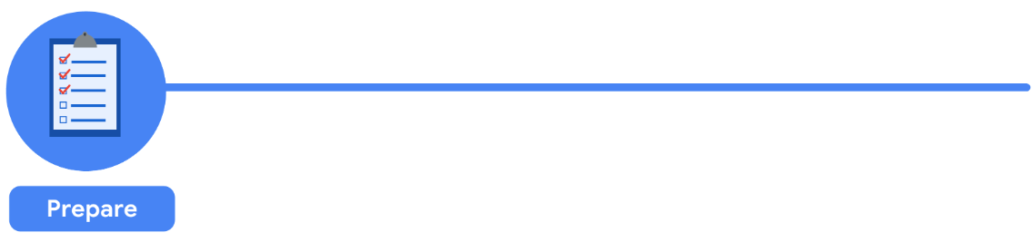**Step 2: Prepare**

You will decide what data you need to collect in order to answer your questions and how to organize it so that it is useful. You might use your business task to decide:

* What metrics to measure
* Locate data in your database
* Create security measures to protect that data

### **Questions to ask yourself in this step:**

1. What do I need to figure out how to solve this problem?
2. What research do I need to do?

## 

## **Step 3: Process**

Clean data is the best data and you will need to clean up your data to get rid of any possible errors, inaccuracies, or inconsistencies. This might mean:

* Using spreadsheet functions to find incorrectly entered data
* Using SQL functions to check for extra spaces
* Removing repeated entries
* Checking as much as possible for bias in the data

### **Questions to ask yourself in this step:**

1. What data errors or inaccuracies might get in my way of getting the best possible answer to the problem I am trying to solve?
2. How can I clean my data so the information I have is more consistent?

## **Step 4: Analyze**

You will want to think analytically about your data. At this stage, you might sort and format your data to make it easier to:

* Perform calculations
* Combine data from multiple sources
* Create tables with your results

### **Questions to ask yourself in this step:**

1. What story is my data telling me?
2. How will my data help me solve this problem?
3. Who needs my company’s product or service? What type of person is most likely to use it?

## **Step 5: Share**

Everyone shares their results differently so be sure to summarize your results with clear and enticing visuals of your analysis using data via tools like graphs or dashboards. This is your chance to show the stakeholders you have solved their problem and how you got there. Sharing will certainly help your team:

* Make better decisions
* Make more informed decisions
* Lead to stronger outcomes
* Successfully communicate your findings

### **Questions to ask yourself in this step:**

1. How can I make what I present to the stakeholders engaging and easy to understand?
2. What would help me understand this if I were the listener?



## **Step 6: Act**

Now it’s time to act on your data. You will take everything you have learned from your data analysis and put it to use. This could mean providing your stakeholders with recommendations based on your findings so they can make data-driven decisions.

### **Questions to ask yourself in this step:**

1. How can I use the feedback I received during the share phase (step 5) to actually meet the stakeholder’s needs and expectations?

These six steps can help you to break the data analysis process into smaller, manageable parts, which is called **STRUCTURED THINKING**. This process involves four basic activities:

1. **Recognizing the current problem or situation**
2. **Organizing available information**
3. **Revealing gaps and opportunities**
4. **Identifying your options**

When you are starting out in your career as a data analyst, it is normal to feel pulled in a few different directions with your role and expectations. Following processes like the ones outlined here and using structured thinking skills can help get you back on track, fill in any gaps and let you know exactly what you need.

SOLVE PROBLEMS WITH DATA

An **important part** of this process is **strong problem-solving skills**. As a data analyst, you'll find that problems are at the center of what you do every single day, but that's a good thing.

Think of problems as opportunities to put your skills to work and find creative and insightful solutions. Problems can be small or large, simple or complex, no problem is like another and they all require a slightly different approach but **the first step is always the same:** Understanding what kind of problem you're trying to solve.

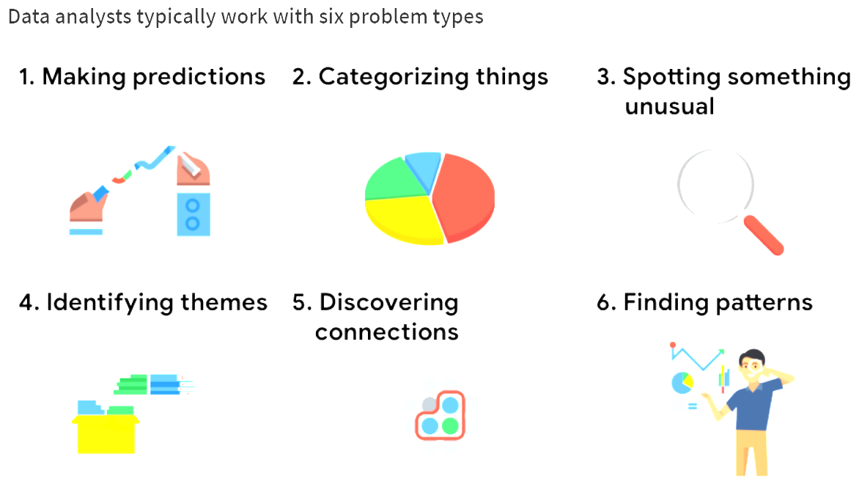

**SIX COMMON PROBLEM TYPES :**

**Making predictions:** This problem type involves using data to make an informed decision about how things may be in the future.   
**Example:** A company that wants to know the best advertising method to bring in new customers is an example of a problem requiring analysts to make predictions. Analysts with data on location, type of media, and number of new customers acquired as a result of past ads can't guarantee future results, but they can help predict the best placement of advertising to reach the target audience.

**Categorizing things:** This means assigning information to different groups or clusters based on common features.   
**Example:** A company's goal to improve customer satisfaction. Analysts might classify customer service calls based on certain keywords or scores. This could help identify top-performing customer service representatives or help correlate certain actions taken with higher customer satisfaction scores.

**Spotting something unusual:** In this problem type, data analysts identify data that is different from the norm.  
**Example:** A company that sells smart watches that help people monitor their health would be interested in designing their software to spot something unusual. Analysts who have analyzed aggregated health data can help product developers determine the right algorithms to spot and set off alarms when certain data doesn't trend normally

**Identifying themes:** Identifying themes takes categorization as a step further by grouping information into broader concepts.  
**Example:** User experience (UX) designers might rely on analysts to analyze user interaction data. Similar to problems that require analysts to categorize things, usability improvement projects might require analysts to identify themes to help prioritize the right product features for improvement. Themes are most often used to help researchers explore certain aspects of data. In a user study, user beliefs, practices, and needs are examples of themes.

By now you might be wondering if there is a difference between categorizing things and identifying themes. **The best way to think about it is: categorizing things involves assigning items to categories**; identifying themes takes those categories a step further by grouping them into broader themes.

**Discovering connections:** The problem type of discovering connections enables data analysts to find similar challenges faced by different entities, and then combine data and insights to address them.  
**Example:** A third-party logistics company working with another company to get shipments delivered to customers on time is a problem requiring analysts to discover connections. By analyzing the wait times at shipping hubs, analysts can determine the appropriate schedule changes to increase the number of on-time deliveries.

**Finding patterns:** Data analysts use data to find patterns by using historical data to understand what happened in the past and is therefore likely to happen again.  
**Example:** Minimizing downtime caused by machine failure is an example of a problem requiring analysts to find patterns in data. For example, by analyzing maintenance data, they might discover that most failures happen if regular maintenance is delayed by more than a 15-day window.

HOW TO CRAFT EFFECTIVE QUESTIONS

Now that we've talked about six basic problem types, it's time to start solving them.To do that, data analysts start by **asking the right questions.**

If someone requests that I work on a project, I ask questions to make sure we're on the same page about the plan and the goals. And when I do get a result, I question it. Is the data showing me something superficially? Is there a conflict somewhere that needs to be resolved? The more questions you ask, the more you'll learn about your data and the more powerful your insights will be at the end of the day. **Some questions are more effective than others.**  
**Leading Question:**"These are the best sandwiches ever, aren't they?" Well, that question doesn't really give you the opportunity to share your own opinion, especially if you happen to disagree and didn't enjoy the sandwich very much. This is called a leading question because it's leading you to answer in a certain way. Or maybe you're working on a project and you decide to interview a family member.

Say you ask your uncle, did you enjoy growing up in Malaysia? He may reply, "Yes." But you haven't learned much about his experiences there. Your question was **closed-ended**. That means it can be answered with a yes or no. These kinds of questions rarely lead to valuable insights. Now what if someone asks you, do you prefer chocolate or vanilla? Well, what are they specifically talking about? Ice cream, pudding, coffee flavoring or something else? What if you like chocolate ice cream but vanilla in your coffee? What if you don't like either flavor? That's the problem with this question. It's too vague and lacks context. **Knowing the difference between effective and ineffective questions is essential for your future career as a data analyst.**

**EFFECTIVE QUESTIONS FOLLOW THE SMART METHODOLOGY**

That means they're **SMART**:

1. **Specific: They are simple, significant and focused on a single topic or a few closely related ideas.** This helps us collect information that's relevant to what we're investigating. If a question is too general, try to narrow it down by focusing on just one element. For example, instead of asking a closed-ended question, like, are kids getting enough physical activities these days? Ask what percentage of kids achieve the recommended 60 minutes of physical activity at least five days a week? That question is much more specific and can give you more useful information.
2. **Measurable: They can be quantified and assessed**. An example of an unmeasurable question would be, why did a recent video go viral? Instead, you could ask how many times was our video shared on social channels the first week it was posted? That question is measurable because it lets us count the shares and arrive at a concrete number.
3. **Action-oriented: They encourage change**. You might remember that problem solving is about seeing the current state and figuring out how to transform it into the ideal future state. Well, action-oriented questions help you get there. So rather than asking, how can we get customers to recycle our product packaging? You could ask, what design features will make our packaging easier to recycle? This brings you answers you can act on.
4. **Relevant:**They **matter, and they are important and have significance to the problem you're trying to solve**. Let's say you're working on a problem related to a threatened species of frog. And you asked, why does it matter that Pine Barrens tree frogs started disappearing? This is an irrelevant question because the answer won't help us find a way to prevent these frogs from going extinct. A more relevant question would be, what environmental factors changed in Durham, North Carolina between 1983 and 2004 that could cause Pine Barrens tree frogs to disappear from the Sandhills Regions? This question would give us answers we can use to help solve our problem.
5. **Time-bound:**  That's also a great example for our final point, time-bound questions. Time-bound questions specify the time to be studied. The time period we want to study is 1983 to 2004. This limits the range of possibilities and enables the data analyst to focus on relevant data.

There's something else that's **very important to keep in mind when crafting questions**, **FAIRNESS**. It means ensuring that your questions don't create or reinforce bias.

Going back to our sandwich example. There we had an **unfair question** because it was phrased to lead you toward a certain answer. This made it difficult to answer honestly if you disagreed about the sandwich quality. **Another common example of an unfair question is one that makes assumptions**. For instance, let's say a satisfaction survey is given to people who visit a science museum. If the survey asks, what do you love most about our exhibits? This assumes that the customer loves the exhibits which may or may not be true. **Fairness also means crafting questions that make sense to everyone**.

It's important for **questions to be clear and have a straightforward wording that anyone can easily understand**. Unfair questions also can make your job as a data analyst more difficult. They lead to unreliable feedback and missed opportunities to gain some truly valuable insights.

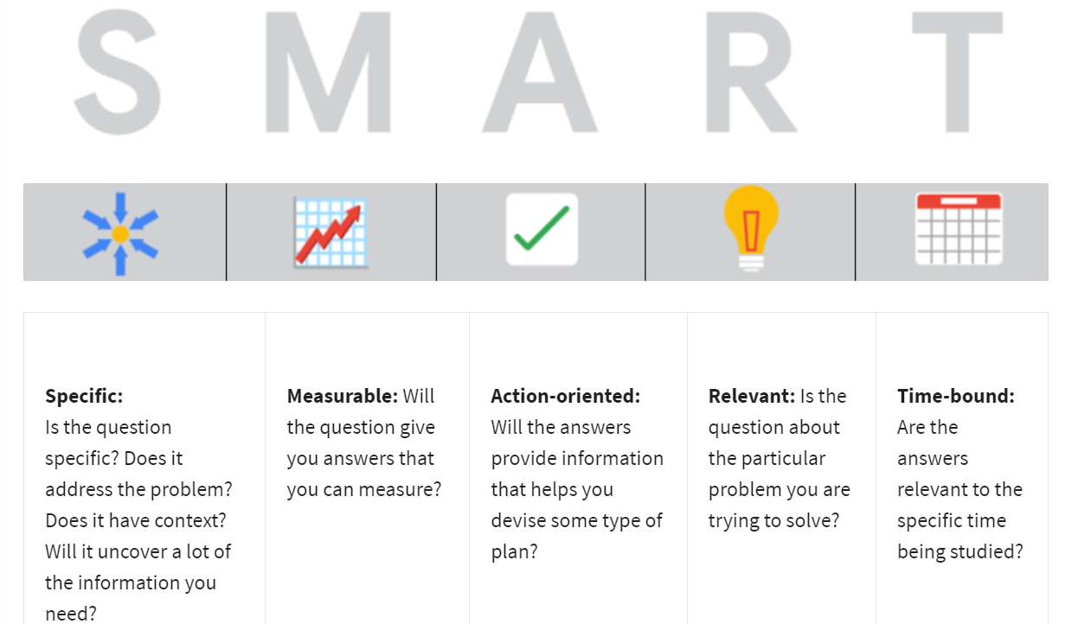

## **Examples of SMART questions**

Here's an example that breaks down the thought process of turning a problem question into one or more SMART questions using the SMART method: **What features do people look for when buying a new car?**

* **Specific**: Does the question focus on a particular car feature?
* **Measurable**: Does the question include a feature rating system?
* **Action-oriented**: Does the question influence creation of different or new feature packages?
* **Relevant**: Does the question identify which features make or break a potential car purchase?
* **Time-bound**: Does the question validate data on the most popular features from the last three years?

Questions should be **open-ended.** This is the best way to get responses that will help you accurately qualify or disqualify potential solutions to your specific problem. So, based on the thought process, possible SMART questions might be:

* On a scale of 1-10 (with 10 being the most important) how important is your car having four-wheel drive? Explain.
* What are the top five features you would like to see in a car package?
* What features, if included with four-wheel drive, would make you more inclined to buy the car?
* How does a car having four-wheel drive contribute to its value, in your opinion?

## **Things to avoid when asking questions**

**Leading questions**: questions that only have a particular response

* Example: **This product is too expensive, isn’t it?**

This is a leading question because it suggests an answer as part of the question. A better question might be, “What is your opinion of this product?” There are tons of answers to that question, and they could include information about usability, features, accessories, color, reliability, and popularity, on top of price. Now, if your problem is actually focused on pricing, you could ask a question like “What price (or price range) would make you consider purchasing this product?” This question would provide a lot of different measurable responses.

**Closed-ended questions**: questions that ask for a one-word or brief response only

* Example: **Were you satisfied with the customer trial?**

This is a closed-ended question because it doesn’t encourage people to expand on their answer. It is really easy for them to give one-word responses that aren’t very informative. A better question might be, “What did you learn about customer experience from the trial.” This encourages people to provide more detail besides “It went well.”

**Vague questions:** questions that aren’t specific or don’t provide context

* Example: **Does the tool work for you?**

This question is too vague because there is no context. Is it about comparing the new tool to the one it replaces? You just don’t know. A better inquiry might be, “When it comes to data entry, is the new tool faster, slower, or about the same as the old tool? If faster, how much time is saved? If it's slower, how much time is lost?” These questions give context (data entry) and help frame responses that are measurable (time).

TEST:  
**Ask the right type of questions**



You can apply the SMART framework to all types of questions. The type of questions you ask can help you explore deeper with your data. Consider the ways your questions help you examine objectives, audience, time, security, and resources.

Some common topics for questions include:

* Objectives
* Audience
* Time
* Resources
* Security

Think about how you can ask SMART questions about each of these topics.

**3 DIFFERENT CORE ROLES:**

DATA ANALYST = works with SQL, Spreadsheets, SML DBs

DATA ENGINEERS =

DATA SCIENTIST = turn data into machine learning models or statistical inferences.

# Glossary terms from module 1

## Terms and definitions for Course 2, Module 1

**Action-oriented question:** A question whose answers lead to change

**Cloud:** A place to keep data online, rather than a computer hard drive

**Data analysis process:** The six phases of ask, prepare, process, analyze, share, and act whose purpose is to gain insights that drive informed decision-making

**Data life cycle:** The sequence of stages that data experiences, which include plan, capture, manage, analyze, archive, and destroy

**Leading question:** A question that steers people toward a certain response

**Measurable question:** A question whose answers can be quantified and assessed

**Problem types:** The various problems that data analysts encounter, including categorizing things, discovering connections, finding patterns, identifying themes, making predictions, and spotting something unusual

**Relevant question:** A question that has significance to the problem to be solved

**SMART methodology:** A tool for determining a question’s effectiveness based on whether it is specific, measurable, action-oriented, relevant, and time-bound

**Specific question:** A question that is simple, significant, and focused on a single topic or a few closely related ideas

**Structured thinking:** The process of recognizing the current problem or situation, organizing available information, revealing gaps and opportunities, and identifying options

**Time-bound question:** A question that specifies a timeframe to be studied

**Unfair question:** A question that makes assumptions or is difficult to answer honestly